**Power-BI-Assignment-4**

**1. Make a simple dashboard and show columns, bar charts, line charts, and area charts.**

[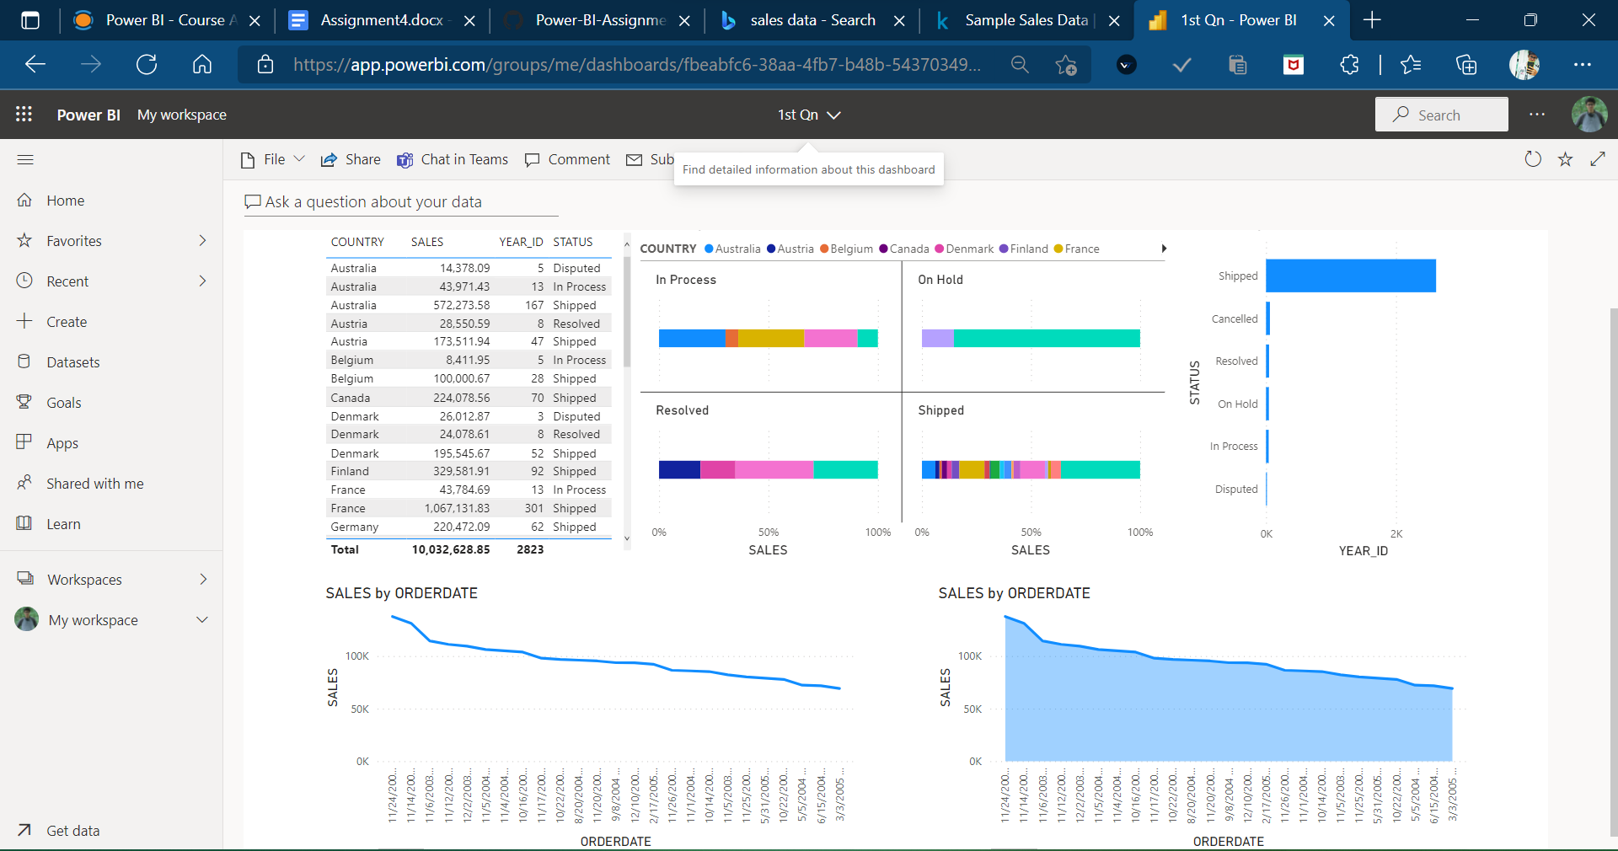](https://user-images.githubusercontent.com/89411580/151604466-e7596fbb-318f-4712-bbeb-5a5ccc43f790.png)

**2. Make a simple dashboard and show combination chart, Scatter chart, Shape chart, and Treemap chart.**

[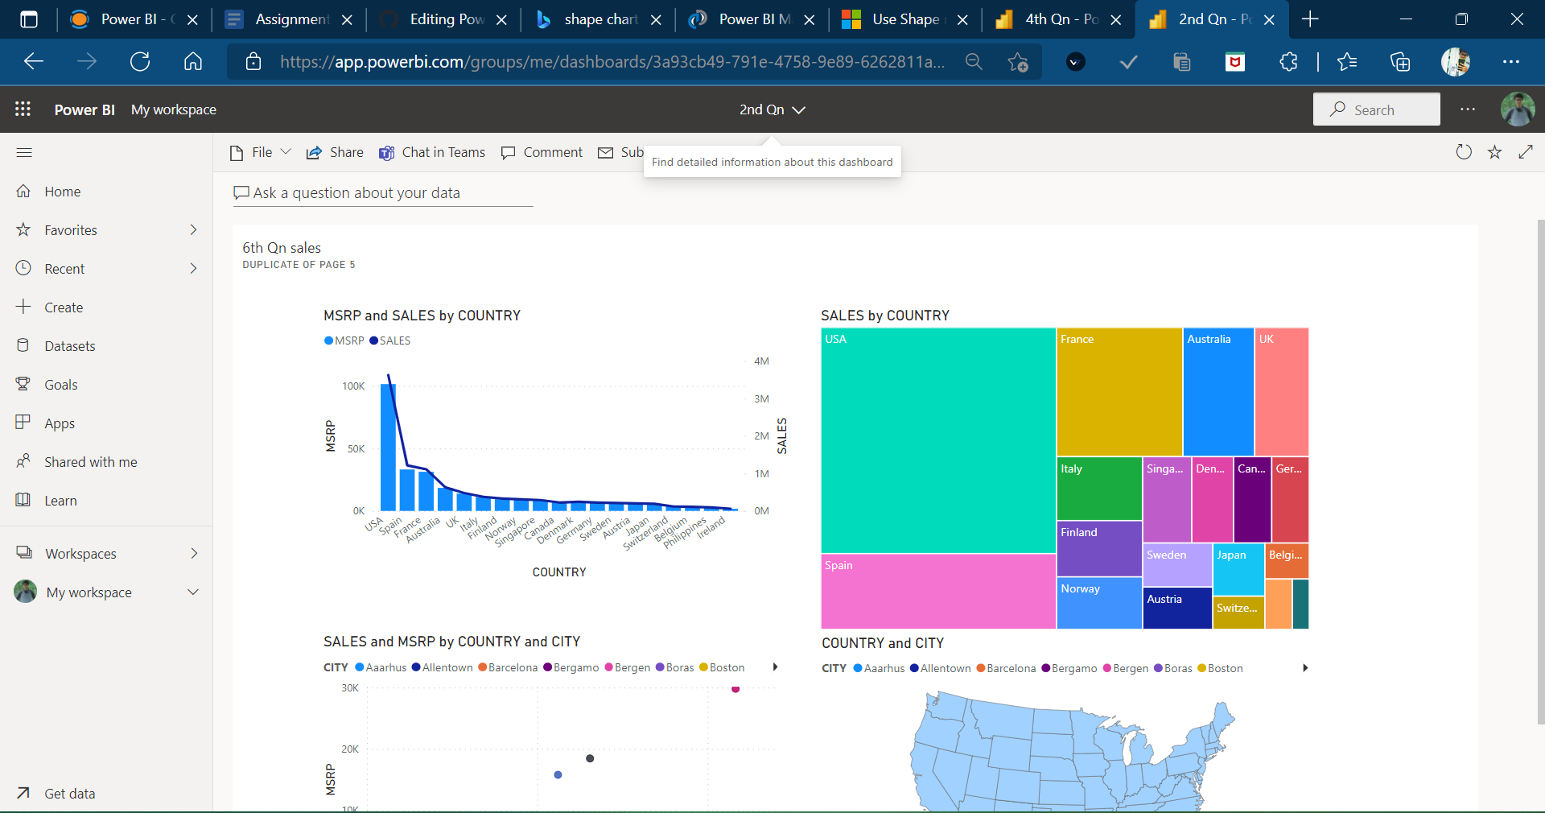](https://user-images.githubusercontent.com/89411580/151608728-4ada0a47-a0d4-43e6-afd3-e5ce48c5bbae.png)

**3. Make a dashboard and show 2 maps visualization i.e. basic map and filler maps**

[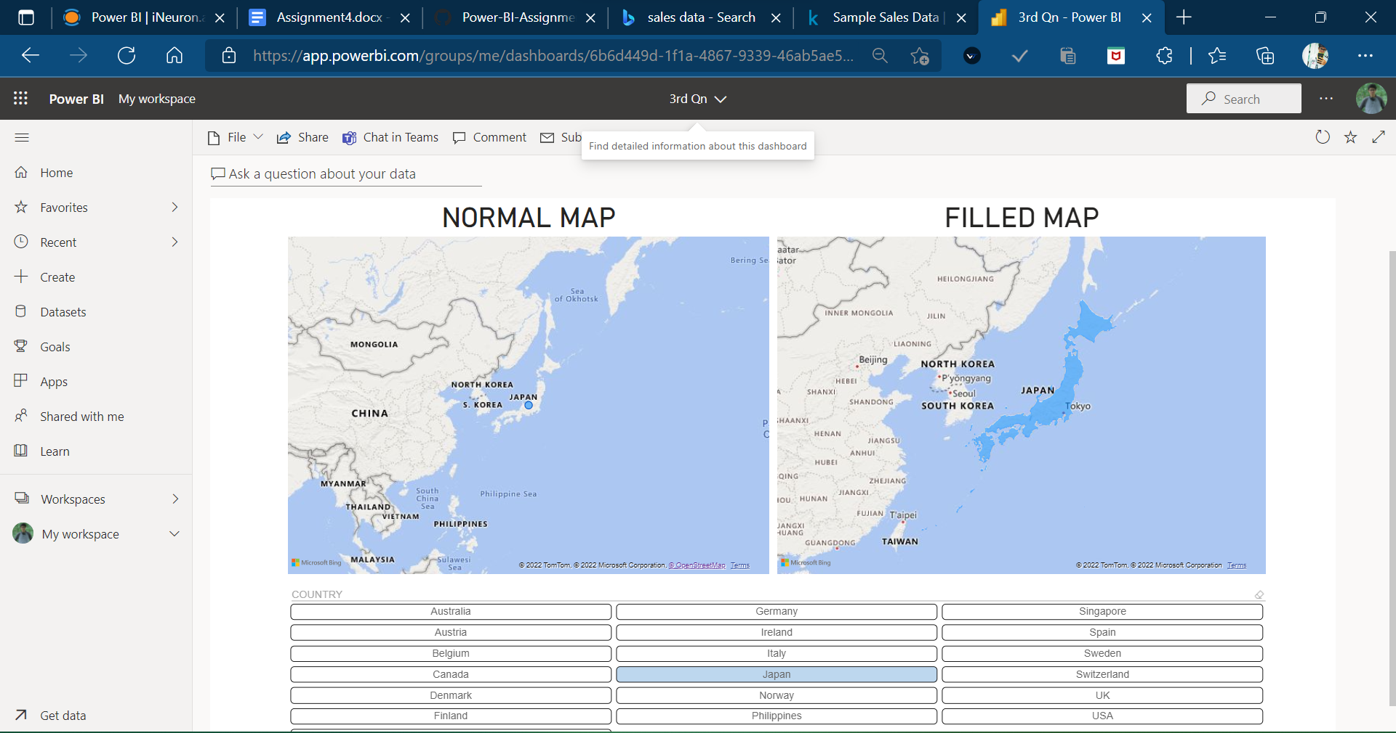](https://user-images.githubusercontent.com/89411580/151603065-a2119672-b07c-4d07-ba6e-506f552047f7.png)

**4. Create a report which has:**

**- Bar chart**

**- Card visualizations**

**- Combo chart visualizations**

**- Matrix visualizations**

**- Column chart visualizations**

**guide: Sales data can be used**

[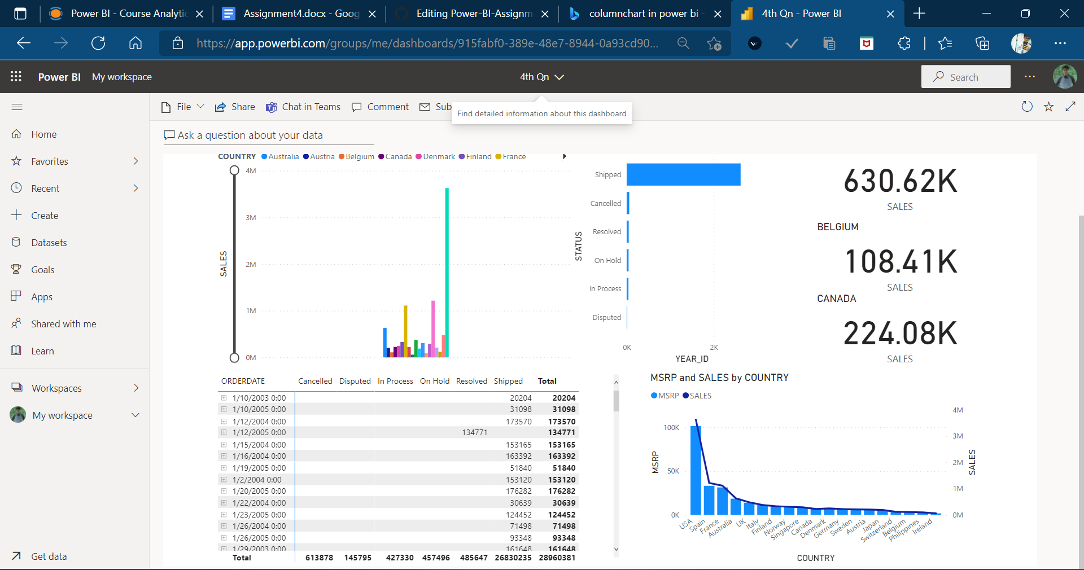](https://user-images.githubusercontent.com/89411580/151606923-39434bdb-f5dc-4114-a0a2-808badea03e8.png)

**5. Make a report to analyze product sales using treemap visualization.**

[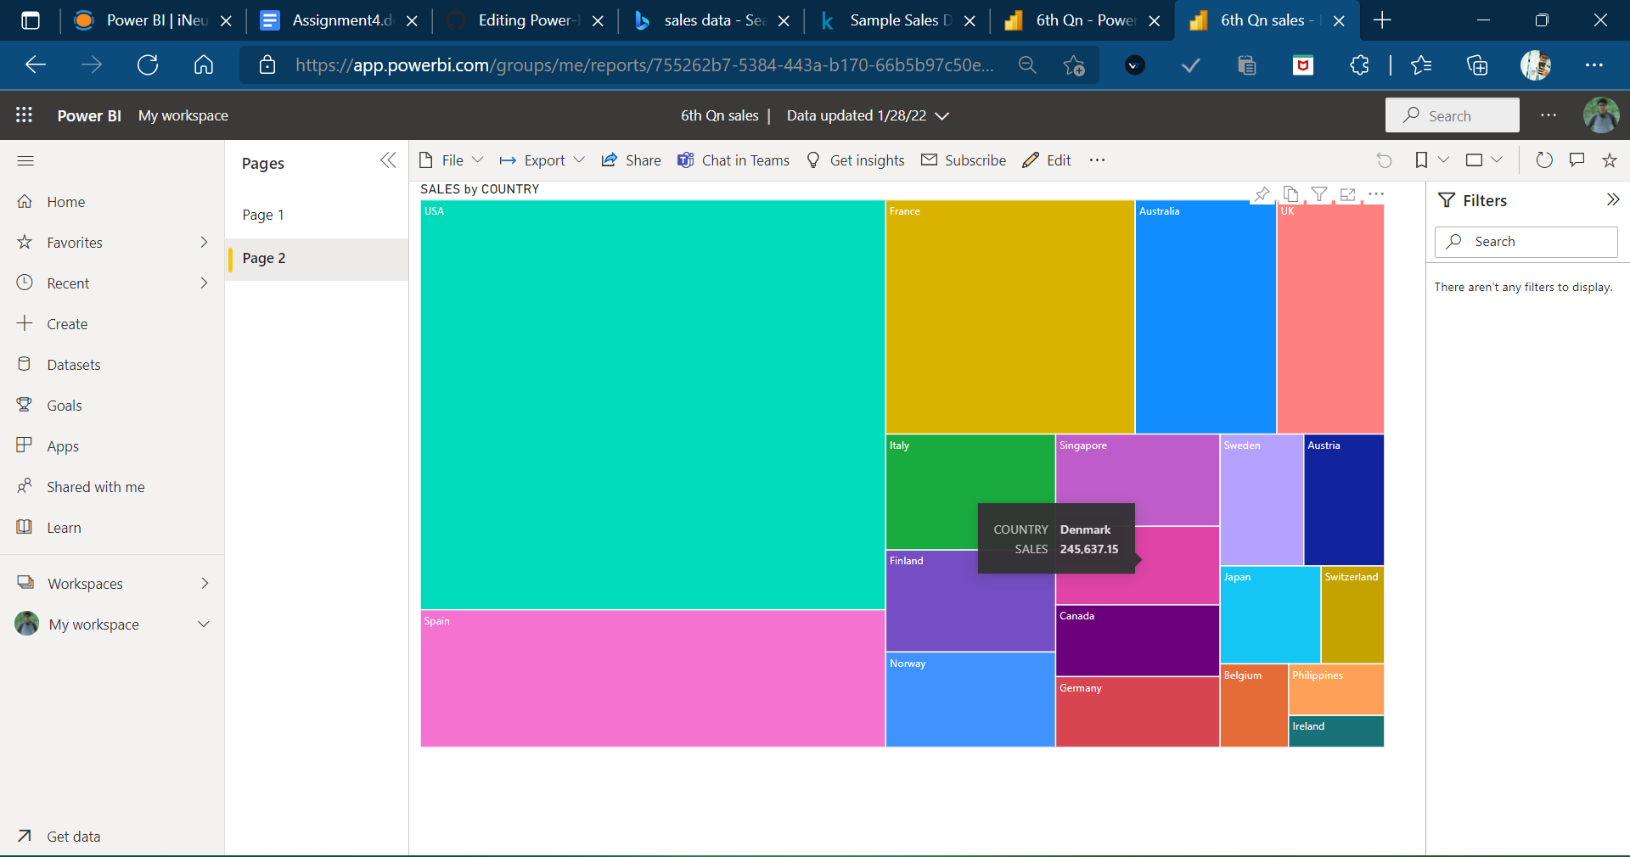](https://user-images.githubusercontent.com/89411580/151601091-c71a3b63-2d21-4f39-baa6-2aa89cb2f3a6.png)

**6. Make a dashboard on sales data (Minimum 4 tiles).**

[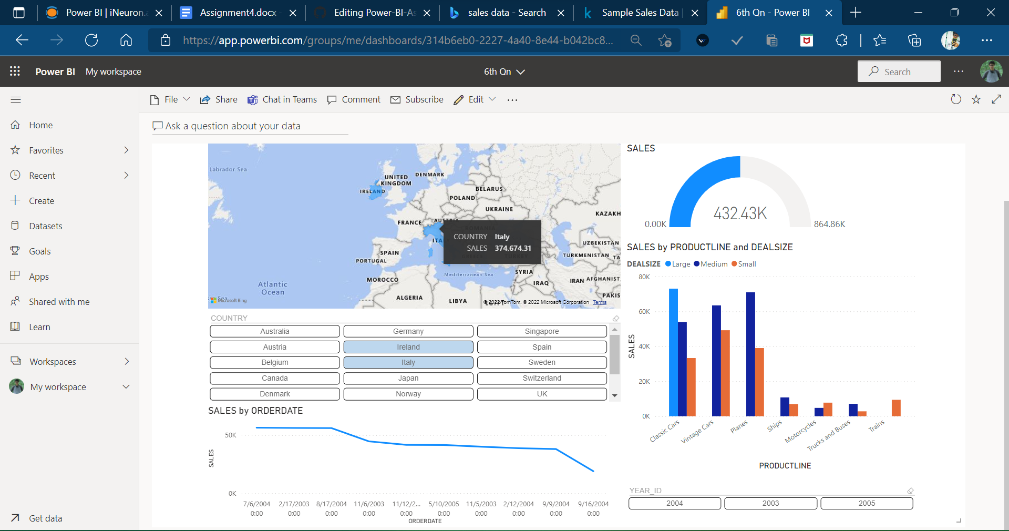](https://user-images.githubusercontent.com/89411580/151600639-233f33f6-978a-48c9-ae5f-1f251c02a252.png)